Registration Form
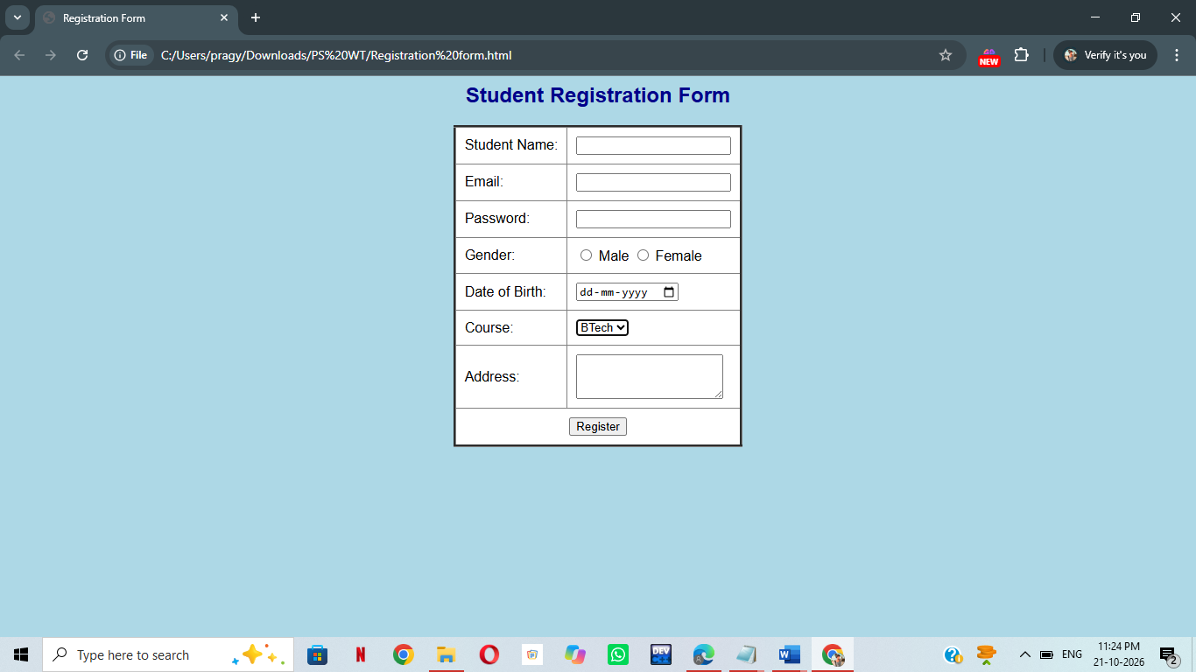

<html>
<head>
<title>Registration Form</title>
<style>
body {
background-color: lightblue;
font-family: Arial;
}
h2 {
text-align: center;
color: darkblue;
}
table {
background-color: white;
border-collapse: collapse;
margin: auto;
}
td {
padding: 10px;
}
input[type="submit"]
input[type="reset"] {
background-color: pink;
}
</style>
</head>
<body>
<h2>Student Registration Form</h2>
<table border="3" cellpadding="10">
<form>
<tr>
<td>Student Name:</td>
<td><input type="text" name="name"></td>
</tr>
<tr>
<td>Email:</td>
<td><input type="email" name="email"></td>
</tr>
<tr>
<td>Password:</td>
<td><input type="password" name="password"></td>
</tr>
<tr>
<td>Gender:</td>
<td>
<input type="radio" name="gender" value="Male"> Male
<input type="radio" name="gender" value="Female"> Female
</td>
</tr>
<tr>
<td>Date of Birth:</td>
<td><input type="date" name="dob"></td>
</tr>
<tr>
<td>Course:</td>
<td>
<select name="course">
<option>BTech</option>
<option>BCA</option>
<option>BBA</option>
</select>
</td>
</tr>
<tr>
<td>Address:</td>
<td><textarea name="address" rows="3"></textarea></td>
</tr>
<tr>
<td colspan="2" align="center">
<input type="submit" value="Register">
</td>
</tr>
</form>
</table>
</body>
</html>

Frames

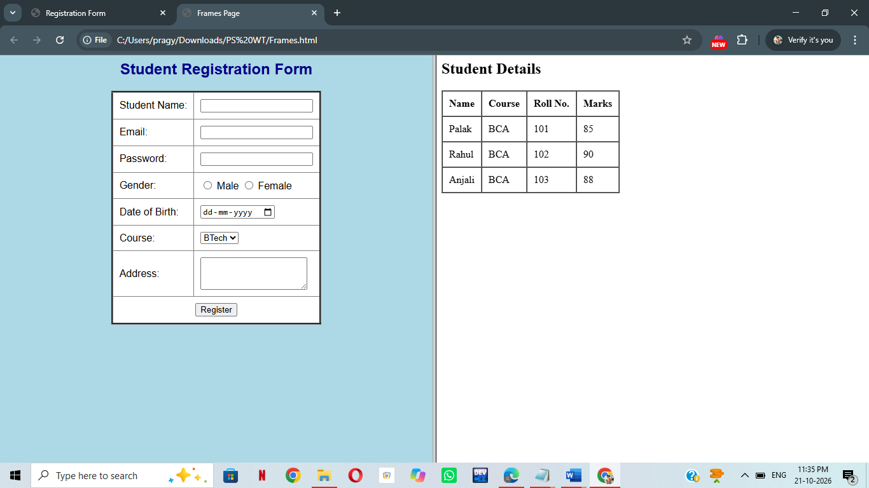

<html>
<head>
<title>Frames Page</title>
</head>
<frameset cols="50%,50%">
<frame src="registration form.html">
<frame src="table.html">
</frameset>
</html>

